21 테스트(test) 코드 작성하기

**테스트 코드 작성하기**

**미션**

Article 서비스를 검증하는 테스트 코드를 작성하시오.  
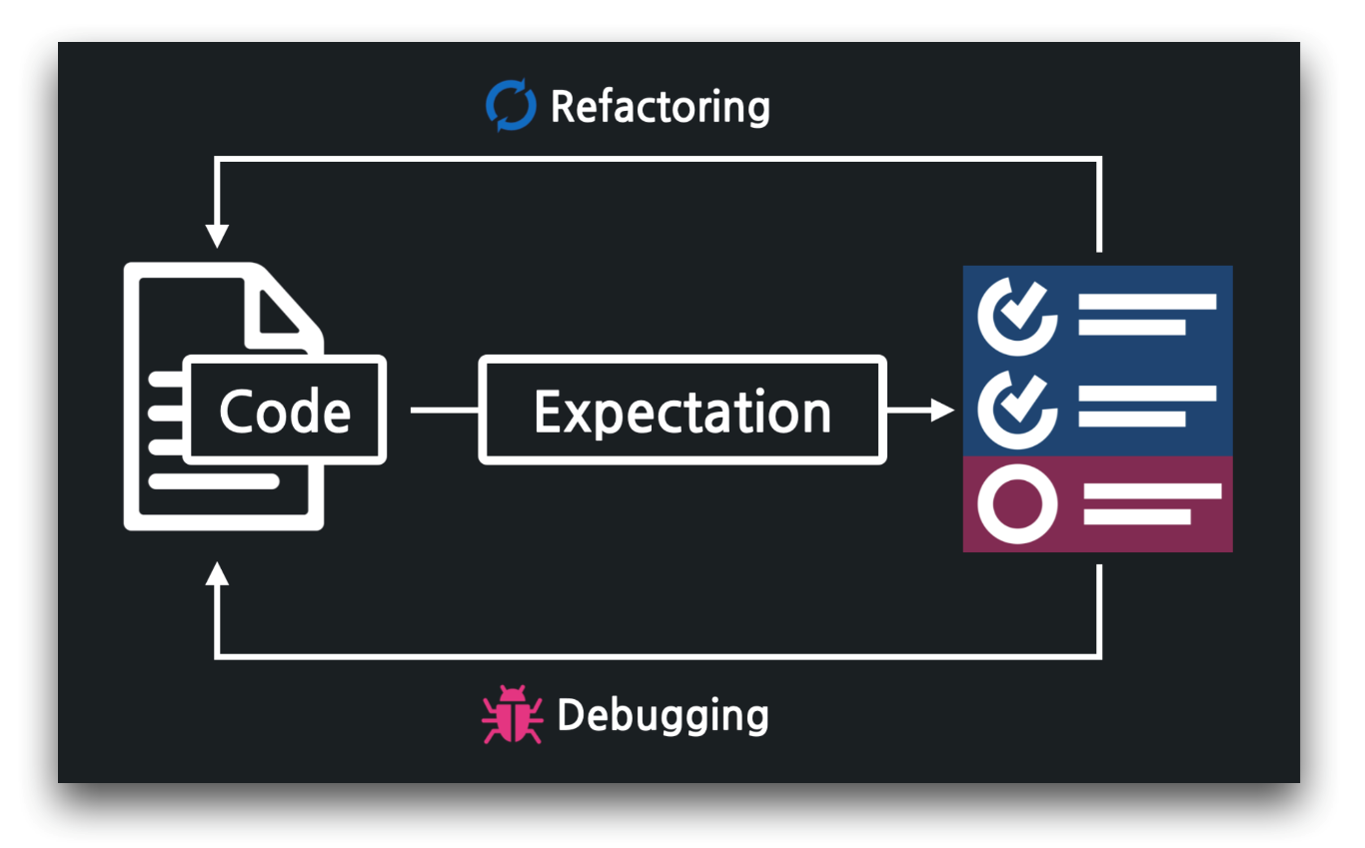

**02:51 테스트 코드 틀잡기 - @Test, @SpringBootTest**

../test/…/service/ArticleServiceTest

1. package com.example.firstproject.service;
2. import org.junit.jupiter.api.Test;
3. import org.springframework.beans.factory.annotation.Autowired;
4. import org.springframework.boot.test.context.SpringBootTest;
5. import static org.junit.jupiter.api.Assertions.*;
6. @SpringBootTest
7. class ArticleServiceTest {
8. @Autowired
9. ArticleService articleService;
10. @Test
11. void index() {
12. // 예상
13. // 실제
14. // 검증
15. }
16. }

**05:14 index() 테스트**

../test/…/service/ArticleServiceTest

1. ...
2. @SpringBootTest
3. class ArticleServiceTest {
4. ...
5. @Test
6. void index() {
7. // 예상
8. Article a = new Article(1L, "가가가가", "1111");
9. Article b = new Article(2L, "나나나나", "2222");
10. Article c = new Article(3L, "다다다다", "3333");
11. List<Article> expected = new ArrayList<Article>(Arrays.asList(a, b, c));
12. // 실제
13. List<Article> articles = articleService.index();
14. // 검증
15. assertEquals(expected.toString(), articles.toString());
16. }
17. }

**09:54 show() 테스트**

../test/…/service/ArticleServiceTest

1. ...
2. @SpringBootTest
3. class ArticleServiceTest {
4. ...
5. @Test
6. void show_성공____존재하는_id_입력() {
7. // 예상
8. Long id = 1L;
9. Article expected = new Article(id, "가가가가", "1111");
10. // 실제
11. Article article = articleService.show(id);
12. // 비교
13. assertEquals(expected.toString(), article.toString());
14. }
15. @Test
16. void show_실패____존재하지_않는_id_입력() {
17. // 예상
18. Long id = -1L;
19. Article expected = null;
20. // 실제
21. Article article = articleService.show(id);
22. // 비교
23. assertEquals(expected, article);
24. }
25. }

**15:13 create() 테스트**

../test/…/service/ArticleServiceTest

1. ...
2. @SpringBootTest
3. class ArticleServiceTest {
4. ...
5. @Test
6. void create_성공____title과_content만_있는_dto_입력() {
7. // 예상
8. String title = "라라라라";
9. String content = "4444";
10. ArticleForm dto = new ArticleForm(null, title, content);
11. Article expected = new Article(4L, title, content);
12. // 실제
13. Article article = articleService.create(dto);
14. // 비교
15. assertEquals(expected.toString(), article.toString());
16. }
17. @Test
18. void create_실패____id가_포함된_dto_입력() {
19. // 예상
20. String title = "라라라라";
21. String content = "4444";
22. ArticleForm dto = new ArticleForm(4L, title, content);
23. Article expected = null;
24. // 실제
25. Article article = articleService.create(dto);
26. // 비교
27. assertEquals(expected, article);
28. }
29. }